ComplianceMAX: Each Advisor (or Branch) using the Client Loyalty Magazine Gift Program must submit a request for approval via WFA ComplianceMAX.
See below three approved templates: first template/form is for Wells Fargo Advisors, second template/form is for Wells Fargo Advisors Financial Network, and third template/form is for Wealth Management Group of Wells Fargo Advisors.
Complete and return the appropriate label form to rob@magazine-loyaltyprogram.com. We will provide your production-ready Loyalty Label and Postcard for you to submit to ComplianceMAX. Minimum purchase of personalized magazine subscriptions or prepay codes may be required.
Wells Fargo Advisors Label Form:
RETURN THE COMPLETED FORM TO rob@magazine-loyaltyprogram.com

Name
Title(s)
Legal Company Name
Preferred Phone
Preferred Email
Website (Optional)
Custom Message | Thank you for your business. I value my relationship with you! (or similar message)
Disclaimer (do not change) | Wells Fargo Advisors is a trade name used by Wells Fargo Clearing Services, LLC, Member SIPC.
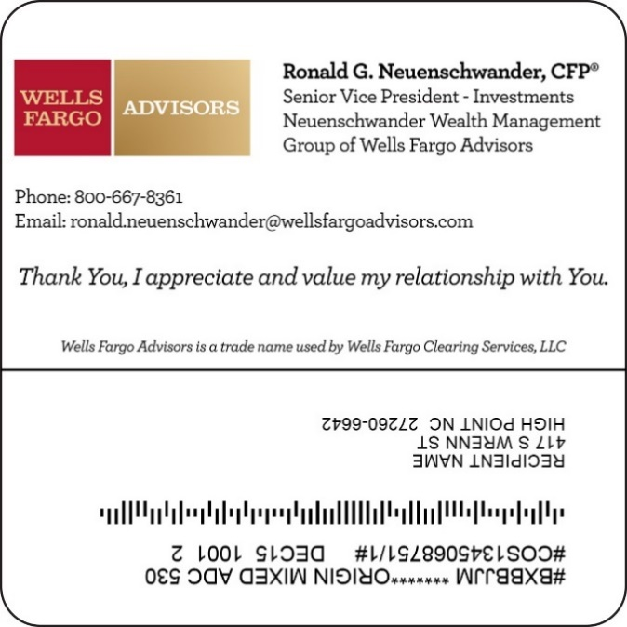

Wells Fargo Advisors Financial Network Label Form:
RETURN THE COMPLETED FORM TO rob@magazine-loyaltyprogram.com

Name
Title(s)
Legal Company Name
Preferred Phone
Preferred Email
Website (Optional)
Custom Message | Thank you for your business. I value my relationship with you! (or similar message)
Disclaimer (do not change) | Wells Fargo Advisors Financial Network, LLC

Wealth Management Group of Wells Fargo Advisors Label Form:

EDIT THE MESSAGE BELOW AND RETURN
THE COMPLETED FORM WITH YOUR COMPANY LOGO TO
rob@magazine-loyaltyprogram.com
A gift from The Lindenberg Wealth
Management Group of Wells Fargo Advisors.
Thank you for your business.
We appreciate our relationship with you.
(or similar)

Wells Fargo Advisors is a trade name used by Wells Fargo Clearing Services, LLC

